Legend

Prereq 0.x – Icons & Preamble
Prereq 0.1 – Starting your practice/competition
Prereq 0.2 – Team ID
Prereq 0.3 – General things to avoid
Prereq 0.4 – Scoring report
1.x – Readme
1.1 – Readme Scenario
1.2 – Readme Critical Services
1.3 – Readme Users
2 – Forensic questions
3 – Firewall
4 – SSH (Linux only)
5 – Finding unwanted files / Hashes
6 – Removing unwanted programs
7 – Users & Groups
8 – Updating
9 – SMB/Samba shares
10 – Local Security Policy (Windows only)
11 – Roles and Features (Windows only)
12 – Group Policy (Windows only)
13 – Remote Desktop Protocol (Windows only)
14 – Internet Information Services (IIS) Manager (Windows Server only)
15 – Cron (Linux only)
16 – Windows Defender (Windows only)
17 – Windows Services (Windows only)
18 – Listing programs
19 – Ports
20 – Pam/General Security

Prereq 0.x – Icons & Preamble
In this guide, I use Windows and Windows Server interchangably at times because they are very similar.

For this manual, I know some people’s brains work visually and the heavy amounts of text below might get hard to parse, so below are some images to relate to the text. (and to help you navigate the machines) The images on the right represent what each of the virtual machines looks like when the Start/App menu is open.

Windows:


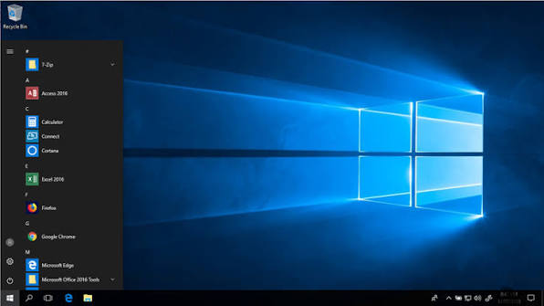
Control Panel

File Explorer
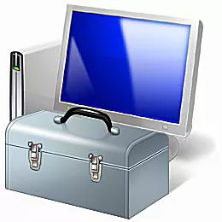
Local Security Policy

Computer Management
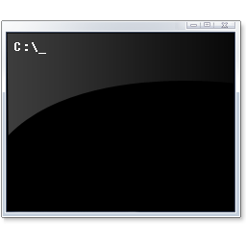
Powershell
Command Prompt

Services

Internet Information Services (IIS)
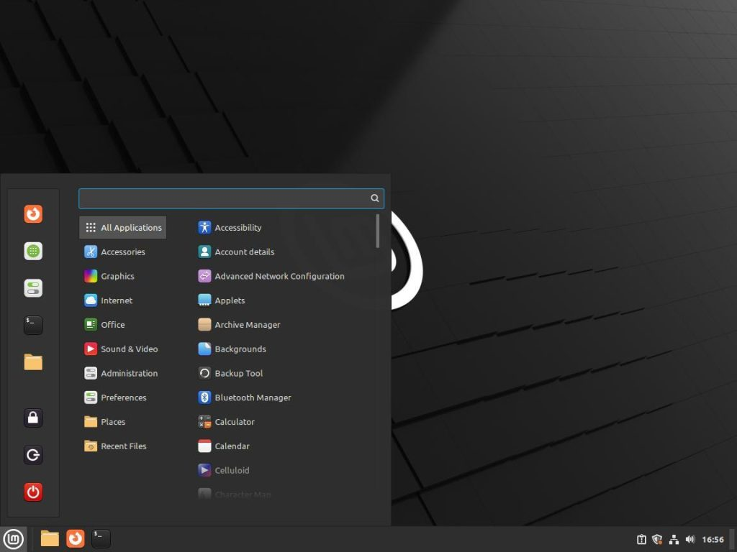
Linux Mint:
Settings/Preferences
File Manager
Terminal
Start Button

Ubuntu:
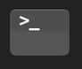
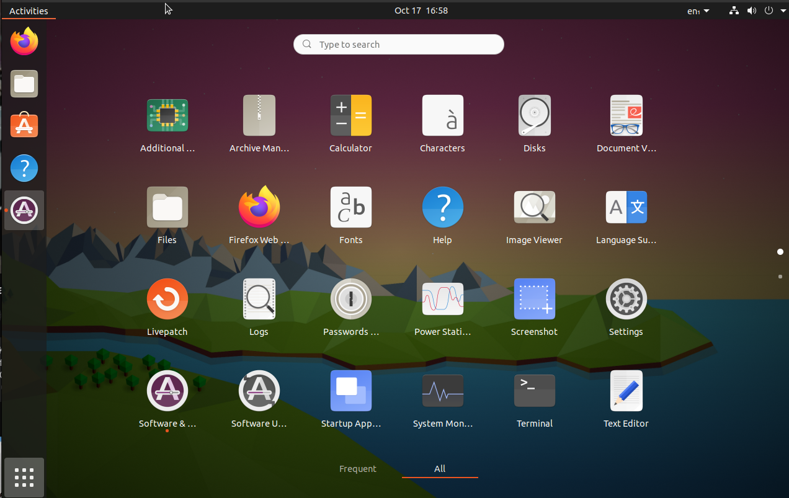
Terminal

Settings

App Menu


Files
Software & Updates

Prereq 0.1 – Starting your practice/competition
Before you can practice or compete, you need to start the scenario’s virtual machine. On your machine’s Desktop you should see a yellow folder with the word “Competition” or “Practice Image” in the name. Click it, and navigate until you see a bunch of loose files. Among these, you should look for one with an icon resembling three windows or squares . This is the icon you should double-click to start up the scenario’s virtual machine. Once VMWare has opened, click the green play button, and the machine will start. You can safely ignore the popups that VMWare will give you.

Prereq 0.2 – Team ID
This is needed before any competition or training may begin. Once you start any virtual machine, you should have a popup to enter your unique ID (found on the front of your team’s booklet under your team’s name) weither automatically or manually through an icon on your desktop. Make sure to:
a) Use your team’s ID. (especially during competition)
b) Use the appropriate ID for the occasion. (practice or competition)

Of note: Some images might say you entered the code correctly and yet still show contradicting information like “This image does not have a README yet” upon opening the README. In that case, try entering your ID again. If that does not work after numerious tries, check to make sure your virtual machine has internet, then consult your team leader or Mr. Simms.

Prereq 0.3 – General things to avoid
Please do not change the password for your user account (see the 1.3-Readme Users) as this could force you to restart from scratch if you forget what it is. Vital things like sudo on linux, or administration prompts on Windows require this.

Please check out the Forensic Question(s) (see section 3-Forensic Questions) before making any changes to the system. For example, if the question requires you to find “goose.exe,” it may become impossible if removed before reading the Forensic Questions.

If you feel lost or have no idea what to do either during competition or during practice then please feel free to talk to your team leader. We will try and get it sorted out the best we can! Also, feel free to search up questions with your preffered search engine on another machine. Google isn’t against the rules!

Prereq 0.4 – Scoring report
The “Scoring report” is one of the few icons on your desktop with a CyberPatriot icon. It contains a log and tally of your current score detailing what you got correct or incorrect. If your scoring report cannot connect to the cyberpatriot servers, your virtual machine may have had it’s internet mismanaged, or your team ID has not been entered yet.

1.x – Readme
The very first thing you should do after entering your team ID is check the README. It is located on the Desktop with a CyberPatriot icon and contains very, very vital information in regards to getting points and destroying the other teams.

It contains what and what not do to at any point during competition or practice. Give every paragraph of the README a read before checking the Forensic Questions and getting some points. The README is normally divided up into sections. The first is usually competition guidelines (The same on every CyberPatriot README, user-made ones may differ), below is a list of the unique sections:

1.1 – Readme Scenario
This section dictates what you can/cannot do in this scenario. For example,
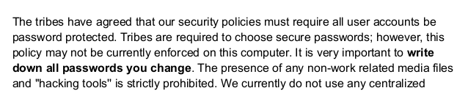

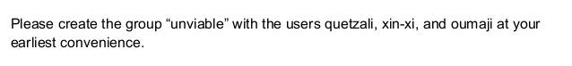

In this example, the scenario dictates that “hacking tools” ought to be removed. (check Section 6-Removing unwanted files) Note: Remember to check the Forensic questions before removing these tools – they might be rquired! It also dictates that all users should have secure passwords. (see section 7-Users & Groups) And, that the group “unviable” should be created with various users. (Also in section 7) Continuing on, most README’s have the version of the system, then more in-depth info.
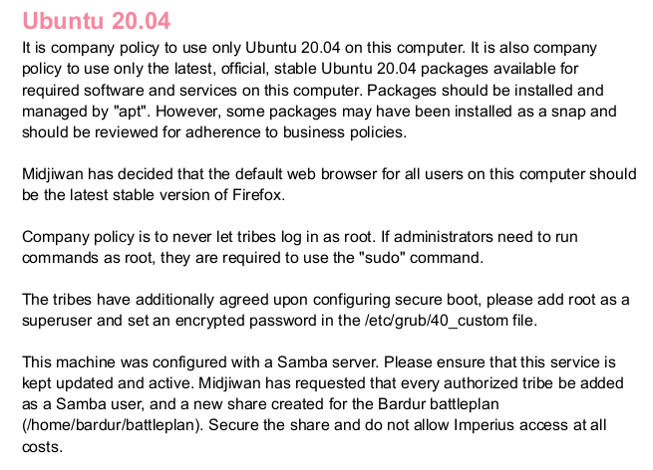

In this example, it details what package sources should be specified. (See section 8-Updating) The default browser is also specified to be Firefox, and that it should be updated. Then, it specifies how samba should be set up. (see 9-SMB/Samba shares)

1.2 – Readme Critical Services
This section should be outlined in bold, and has services that need to be installed/running in point-form. For example, something like:
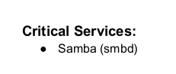
Other examples include:
SSH
Apache
FTP
etc…

This means that the service Samba must stay running at all times.

1.3 – Readme Users
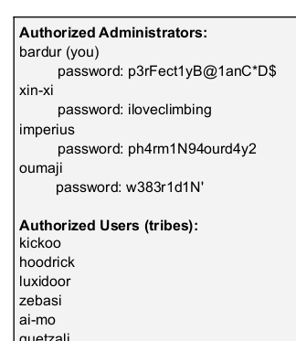

The README specifies a list of users and their passwords, first with Administrators then regular users. It is important to not change your own password as you could get locked out. (Please see section 7-Users)
It will look something like the example on the left. (Passwords and usernames will vary!)

2 – Forensic questions
After checking the README (See 1-Readme 1.x) please open the Forensic Question files found on your Desktop. They give an example question to show how it would be formatted, followed by the actual question. Said question changes depending on the scenario, but they usually involve one of the following:

a) Finding an unauthorized file. (check 5-Finding unwanted files) You may have to provide the file path. Ex:
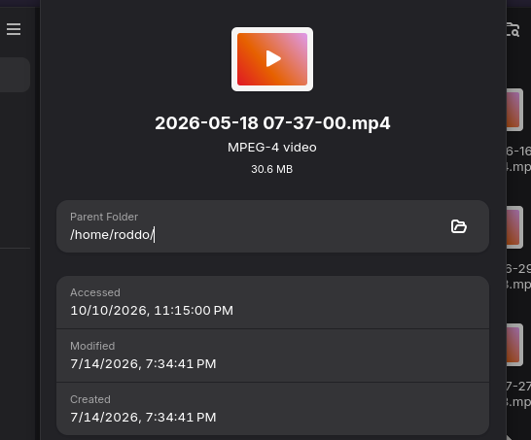
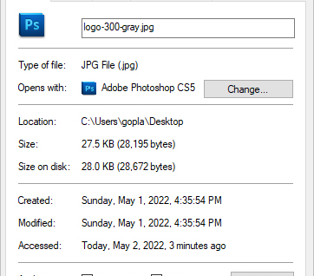

Linux has “Parent Folder” and Windows has “Location.” They both mean the same thing.
If it asks for the file path, add the name of the file to the location provided. Ex:
“/home/cooldude/” + “file.png” → “/home/cooldude/file.png”
If it asks for the Parent folder, simply provide the location folder in the Properties window.

b) Getting the contents of a file. For either Windows or Linux, you should Right-click then “Open with…” with Notepad (or Text Editor on Linux)
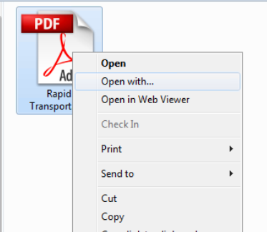
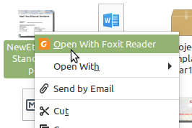

“Open with…” on
Windows

...And on Linux

c) Getting the root of a WebServer (Windows/Server). To do this, use the IIS manager. (Please see 13-Internet Information Services (IIS) Manager)

d) Getting the hash of a file. (To do this, please see 5-Finding unwanted files / Hashes)

3 – Firewall
A firewall simply filters what connections can be made to a computer.

The following is for Linux
Under Linux, use the ufw Terminal command with enable or disable to enable/disable the firewall. This must be ran as root with sudo . Ex:
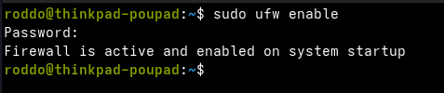

If ufw is not installed, use sudo apt install ufw to install it.

To check your UFW configuration, run sudo ufw status verbose . It should return the following:
Status: active
Logging: on (low)
Default: deny (incoming), allow (outgoing), disabled (routed)
New profiles: skip
The following is for Windows

Under Windows, start up the Control Panel with the start menu then click “System and Security,” Then, click “Windows Defender Firewall.” Once you are at the interface shown below, enable “ Use recommended settings” to get Windows to do all the work for you. Once the button is pressed, the firewall sections should turn green.
Ex.


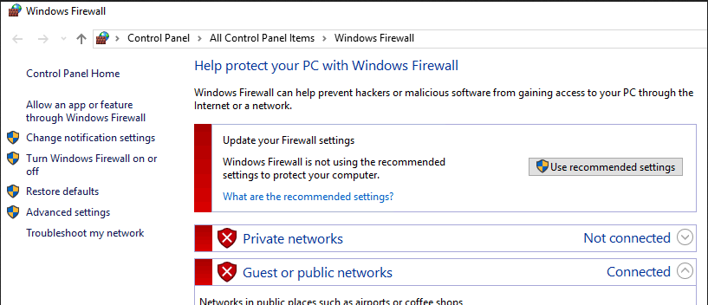

4 – SSH (Linux only)
SSH is the way people access machines across the network on Linux.

Note: Please read the readme (1.2 – Readme Critical Services) to see if SSH is a required service.

To enable ssh, use use the systemctl command.
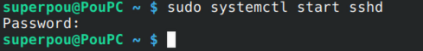

To properly configure SSH, you must edit /etc/ssh/sshd_config . Most of these settings will likely be configured already, but we still need to check each one to make sure. If you add any lines, make sure they go above any Include or Match statements. Essentially, put them at the top of the file. When the settings are read, they work from top to bottom.
Protocol 2
Ciphers -3des-cbc,aes128-cbc,aes192-cbc,aes256-cbc,chacha20-poly1305@openssh.com
ClientAliveInterval 15
ClientAliveCountMax 3
DisableForwarding yes
GSSAPIAuthentication no
HostbasedAuthentication no
IgnoreRhosts yes
KexAlgorithms -diffie-hellman-group1-sha1,diffie-hellman-group14-sha1,diffie-hellman-group-exchange-sha1
LoginGraceTime 60
loglevel VERBOSE
MACs -hmac-md5,hmac-md5-96,hmac-ripemd160,hmac-sha1-96,umac-64@openssh.com,hmac-md5-etm@openssh.com,hmac-md5-96-etm@openssh.com,hmac-ripemd160-etm@openssh.com,hmac-sha1-96-etm@openssh.com,umac-64-etm@openssh.com,umac-128-etm@openssh.com
MaxAuthTries 4
MaxSessions 10
MaxStartups 10:30:60
PermitEmptyPasswords no
PermitRootLogin no
PermitUserEnvironment no
UsePAM yes
After making any changes run the following:
systemctl restart sshd
This will restart the sshd service and apply any changes you have made.
5 – Finding unwanted files / Hashes
In most scenarios, you might have to look for a file to either anwser a Forensic question or to simply delete. The README will say if it permits non-work related files. Please check to see if the forensic questions mention files you find before you delete it!

Common types of unwanted files are (sorted by probability)
.png .jpeg .jpg .mp4 .flac .wav .mov etc…

The following is for Linux
To find a specific file on Linux, you can do it one of two ways. Method one is to use the find command. Follow this skeleton to use it: find /home | grep “file” Note: Linux seperates commands by spaces, so make sure to put your file in quotes if it contains spaces! Ex:
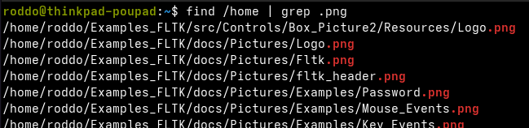
(In my case, I have many image files on my personal computer.)

/home is the place you should be checking since all user data is stored there. To do this graphically, you can use your file manager. You should see “Computer,” or “File System” on the left side of the window. Once you are there, navigate to /home and do a search there. (it may look like a magnifying glass or a folder with a magnifying glass)
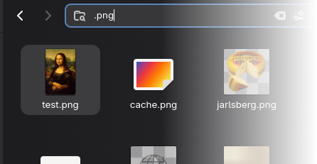
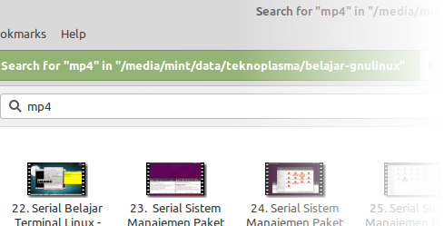
To get the hash of a file on Linux, you can use the following commands depending on what the forensic question specifies:
sha256sum filename
md5sum filename
sha1sum filename
sha512sum filename
All will output the specified hash followed by the filename.

The following is for Windows
Open up File Explorer, then navigate to Local Disk C: Under “This PC”, then to “Users”. You may now search for the prohibited files. (prefixed with “*”!) Ex:
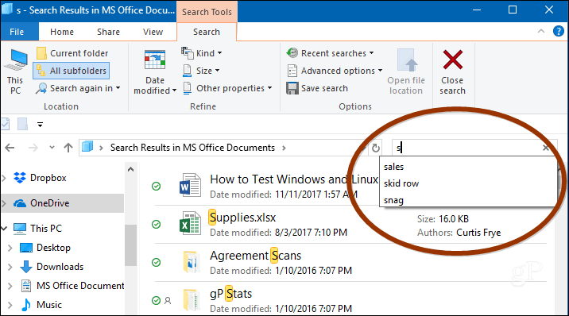
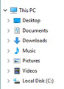

You can also search for files using Powershell on Windows. Using Powershell, we can search for files a lot more quickly and smoothly than by using Explorer. This is often useful for Forensics questions, and allows you to do other work while it searches. The following code searches for a file called "example.html" in the C:\Users directory and all of its subdirectories. You can change the directory to just "C:\" in order to search the entire filesystem. You can also use wildcards (*) in the filename.

Get-ChildItem -Path C:\Users -Filter example.html -Recurse -ErrorAction SilentlyContinue -Force
In Powershell, we can easily find the hash of a file using the following command:
Get-FileHash -Algorithm algorithm filepath
If the hash is asked for, it will specify what algorithm to use in the question.

6 – Removing unwanted programs
Note: Please check the Forensic questions to make sure they don’t require any tools that would be removed here, such as Wireshark or npcap. The readme might also say that certain programs may not be removed. Also, some non-programs count such as Chrome/Firefox extensions.

An “unwanted program” is a program found on the virtual machine that gives points when removed.

The following is for Linux
Under Ubuntu/Linux Mint/debian, apt is the program that you use to remove/add programs. (Or as Linux calls them, “packages”) apt must be ran with sudo . Example for removing programs:
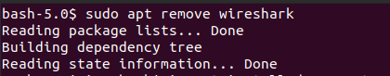
Note: apt requires you to confirm before you remove/add. Type “y” then Enter to continue

List of unwanted software for Linux:
wireshark, nmap, ophcrack, john, wapiti, freeciv, postfix, p0f, netcat, vim
Unwanted games (Ubuntu):
aisleriot, five-or-more, four-in-a-row, gnome-2048, gnome-chess, gnome-klotski, gnome-mahjongg
gnome-mines, gnome-nibbles, gnome-robots, gnome-sudoku, gnome-taquin, gnome-tetravex, hitori, iagno, lightsoff, quadrapassel, swell-foop, tali
Unneeded services (only IF the readme does not mention them):
apache2, sshd, samba, ftpd/proftpd, mysql

The following is for Windows
Under Windows/Server, use the Control Panel to remove unwanted programs. First, click “Uninstall a program”, then right-click on the program you want to remove and click “Uninstall.”

Remember: never uninstall a program that is mentioned as required in the README. You also should not uninstall VMWare Tools, Microsoft Visual C++, or Microsoft .NET.
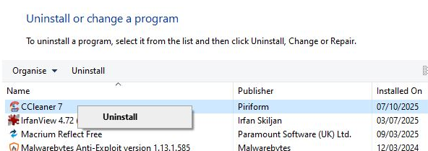

List of unwanted software for Windows:
Wireshark, CCleaner, Cursor, Npcap, Nmap, RainbowCrack, rustscan, qBittorent, Cain and Abel

Note that not all programs might show up in the Control Panel “Programs and Features.” Some might be on the Desktop (Like CCleaner on some images) or hidden away. (like goose.exe)

It is a good idea to go through the C:\Users folders on Windows or the /home directories on Linux to check manually for any suspicious files.
7 – Users & Groups
An easy way to get some points is to set up all the Users. (see 1.3-Readme users to see what the list of users provided by the readme looks like) This involves going to the user management for both Linux and Windows to ensure everyone has a secure password and that they are marked as either administrator or not. You should also check the list of users you see in the Control Panel/User Management against the readme to ensure everyone is accounted for. If a user is missing, add them. If a user is not supposed to be there, remove the account.
Please make sure the Forensic questions don’t require them before removing!
If you do have to remove an account, make sure to keep their files in case you need them later.

The following is for Linux
Under Linux Mint, you need to open the Start menu and click the Settings/Preferences icon on the left. Click on “Users and Groups”. You should be shown a window with the list of users on the left, and configuration for them on the right. From here, you can configure account type (Administrator or Standard) change Passwords, or remove users. Right click the user to bring up the configuration menu on the right. To add users to a group, click the “Groups” tab on the Users and Groups window to add/remove users from groups.
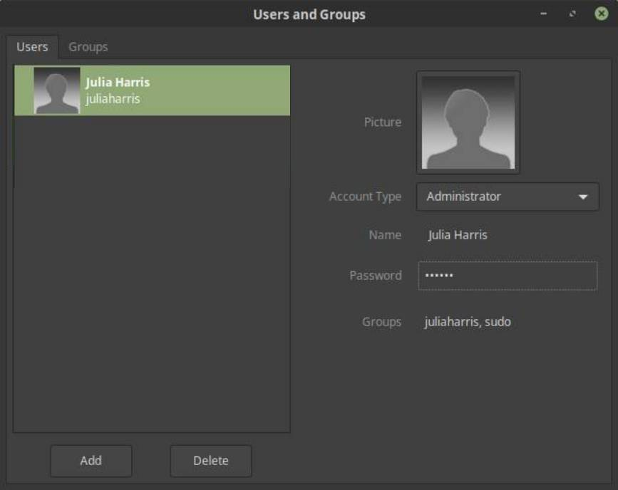
Configuration window:
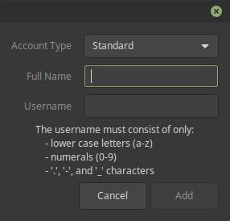

The principles are similar for Ubuntu, it is just the placement of buttons/inputs that changes.

To create a new group on Linux (If the README requires it) use the groupadd command, it takes the group name as an argument (shown below as “groupname”). It must be run with sudo . Once you have made a new group, you can add them in the settings window.
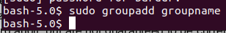
Replace “groupname” with the actual name of the group.

The following is for Windows
Under Windows, user configuration is done via the Control Panel. Open the control panel using the Start Menu and click “User Accounts.” From here, you can double-click a user to change account type change passwords, or remove them. You can also add a new user.

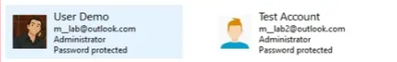

To create a new Group on Windows, you can use the Computer Management program. Once opened with the Start Menu, navigate to Computer Management (Local) → System Tools → Local Users and Groups . From here, you can add new users (offers more control over the Control panel,) create new groups and add users to said groups. You can click on the Users folder get a list of users, and the Groups folder to get a list of groups. Right click on the empty space to get a dialogue where you can add new Users/Groups.

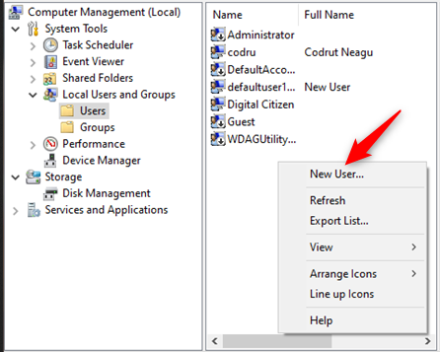

8 – Updating
Note: Please check the readme to see if it mentions keeping programs updated. Common ones are Chrome, Firefox, LibreOffice, 7-zip, Notepad++, etc.
Note: Please only consider updating (especially on Linux) once you have done other less time-consuming tasks, as updating can take a while!

The following is for Linux
Under Linux Mint/Ubuntu you can update the system with the apt command. It must be ran with sudo . First, you must tell it to update the packages it can see.
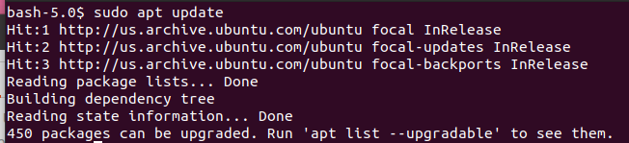
You should see some packages that can be upgraded. In this case, this virtual machine should REALLY ONLY be updated near the end. 450 packages will take some time!

Then, you should commence the actual update process with sudo apt upgrade .
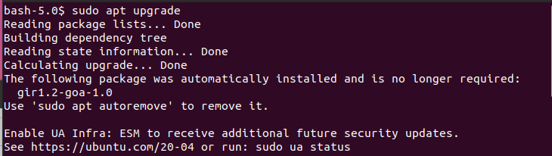
It will spew out all the packages that can be upgraded. Type “y” then Enter to proceed.

Ubuntu and Linux Mint both have something called “Software & Updates.” From here, you can configure when the system updates and what packages it can use. To open this program, search “Software & Updates” in the Linux Mint start menu or the Ubuntu Apps menu.

The README should say what sources should be enabled and what frequency to update here.
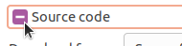
Once opened, check “Source Code” under “Ubuntu Software.”
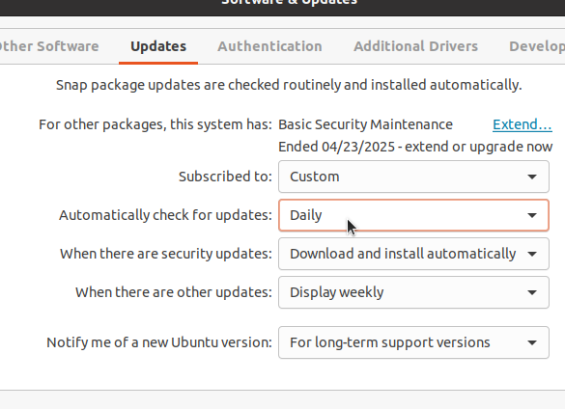

Under “Updates,” make sure it automatically checks for updates Daily, unless the README says otherwise.

The following is for Windows
To update Windows, go to the Start Menu and open Settings on the left, or type in “Settings” and open the program. Navigate to Windows Update and check/install available updates. This will take a while, and it will slow down the computer the whole time. Don't do it right at the start, but don't wait too long either. I recommend letting these run as you eat lunch, or something similar.

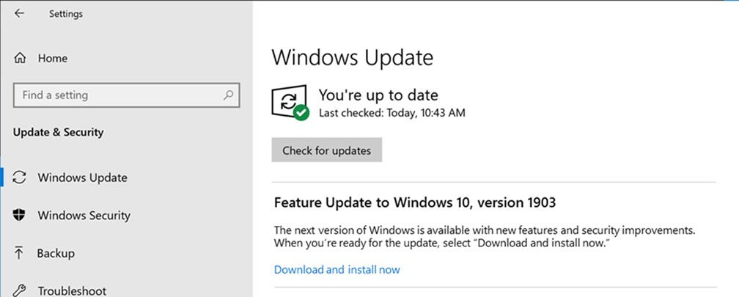

If using Google Chrome, the README will no doubt tell you to keep it up-to-date. To ensure this, open Google Chrome and enter about:policies into the navigation bar, then hit Enter. From here, enable “Automatic Updates.”

Other software is much tougher. For example, to update 7-zip, Notepad++ or Libreoffice, you must ask your team leader for a USB drive that has the newer version’s installer for whatever software on them. This is because the computers on the network have strict filters and have trouble connecting to modern websites.
9 – SMB/Samba shares
The Server Message Block protocol, often called SMB, is a protocol used to share files, share printers, and communicate between processes. It is currently developed by Microsoft, though Samba allows Linux computers to use it as well. Note: Please only enable SMB/Samba if the README requires it!

The following is for Linux
Under Linux, you can start the SMB service using the systemctl command, like so:

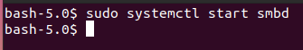
The reason many services on Linux end with “d” is because services on Linux are called Daemons, so smbd means Samba Daemon.

The configuration files for SMB are located at /etc/samba/smb.conf .

The following is for Windows
Using SMB1, the earliest version of SMB, is very risky. It is best to disable it and only use SMB2 or SMB3. In order to do so, you can use the following Powershell command:
Disable-WindowsOptionalFeature -Online -FeatureName SMB1Protocol
Take note that this will restart the computer, so make sure you're not in the middle of anything else!
Some README scenarios or forensic questions may ask about SMB Network Shares. To view/manage network shares, start the Computer Management application by going to the Start Menu and typing “compmgmt.msc”, then open the “Computer Management” application.
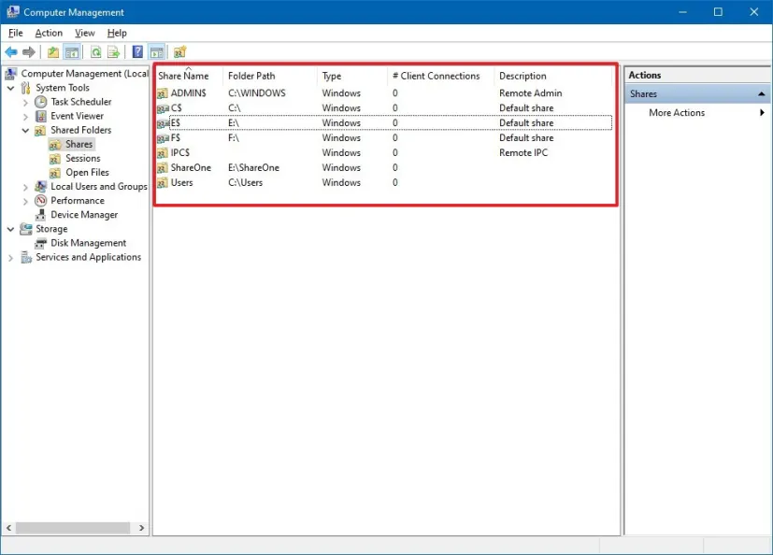
From here, you can add and remove shares. The three defaults are IPC$, C$, and ADMIN$. These do not need to be removed. All others, unless specified in the README, can be removed. Shares with a '$' in them are hidden, and cannot be seen using usual means. They are still accessible, though, and need to be removed just the same.

Enabling SMB signing is very important for security. If somebody tampers with an SMB message while it is in transit, the signing can help your computer notice that something is wrong. This prevents vulnerability to "Man-in-the-Middle" attacks.
In gpedit.msc, go to: Computer Configuration\Windows Settings\Security Settings\Local Policies\Security Options and set "Microsoft network client: Digitally sign communications (always)" to enabled. Or, in Powershell, run:
Set-SmbClientConfiguration -RequireSecuritySignature $true

Authentication Rate Limiter
The authentication rate limiter in SMB does exactly as it says on the tin. It limits how often authentication attempts can be made. This will greatly slow down any brute-force attacks attempted on your system. The timeout should be set short enough that is does not affect regular use.

PowerShell
You can use the following command to set the timeout length in PowerShell:
Set-SmbServerConfiguration -InvalidAuthenticationDelayTimeInMs 2000
That example sets it to 2000 milliseconds (2 seconds), but it can be set to any multiple of 100 within 0 and 10'000.

Group Policy Editor
It can also be set using the Group Policy Editor at this location:
Computer Configuration\Administrative Templates\Network\Lanman Server
Set "Enable authentication rate limiter" to Enabled.
Note that you cannot set the delay time using the Group Policy Editor. It can only be changed in PowerShell.

Encryption
Encrytpting SMB messages is important for preventing third parties from snooping on what files are being accessed and the contents of those files.
Use the following command to enable encryption on compatible SMB servers:
Set-SmbServerConfiguration –EncryptData $true

10 – Local Security Policy (Windows only)
Note: Please check the readme to see if certain password policies are specified
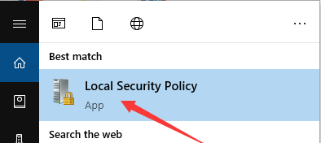
The Local Security Policy is where you will be configuring most of Windows. You can run it by typing “Local Security Policy” into the Start Menu, then clicking the reccomended program.

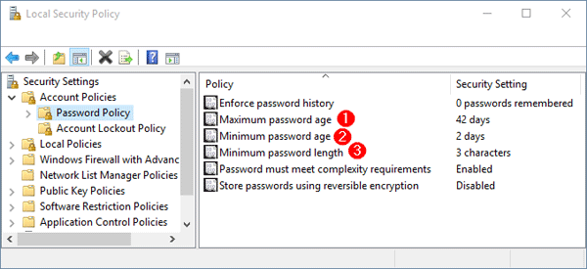
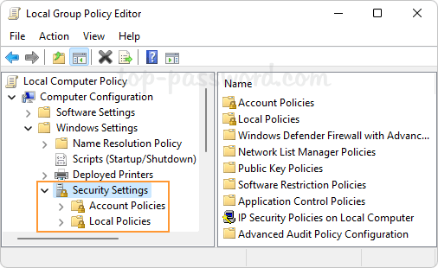

Everything is organized in a file-like view hidden under dropdowns.

The next few pages will be a long list of policies to change. Policies with a ★ (• Example ★) are ones that have been scored vulnerabilities in the past. If you're in a rush, focus on these first.

Account Policies
The policies in the Account Policies branch of secpol relate to password requirements and locking accounts after failed sign-ins.

Password Policies
Included here are the policies defining password requirements. In order, these are:
- Enforce Password History ★
Recommended: 24
This is the number of previous passwords to save, in order to prevent users from rotating between a small number of passwords when asked to change them.
- Maximum Password Age ★
Recommended: 90
This number, in days, is how long a user can keep the same password before being forced to change it. These prevents old, potentially compromised passwords from remaining on the system.
- Minimum Password Age ★
Recommended: 30
This number, in days, is how long after changing a password before a user can change it again.
- Minimum Password Length ★
Recommended: 14
This is the minimum number of characters that a valid password can be. 14, for historical reasons, is the maximum on windows machines. It's also a good length for us.
- Password Must Meet Complexity Requirements ★
Recommended: Enabled
Without this enabled, none of the other password requirements take effect. They're not much use to us unless they're turned on, so make sure to enable this.
- Store Passwords Using Reversible Encryption ★
Recommended: Disabled
Windows already stores the passwords encrypted by default. This makes that encryption reversible, meaning that passwords can be learned just by finding them and unencrypting them. Usually, they're stored using unreversible encryption, so enabling this is a security risk.

Account Lockout Policy
These three policies dictate what should happen after consecutive failed login attempts:
- Account Lockout Duration ★
Recommended: 30
This number, in minutes, is how long the account should be locked out once enough failed logins occur.
- Account Lockout Threshold ★
Recommended: 5
This is how many failed attempts are needed to trigger the account lockout. It shouldn't be too low, otherwise a series of honest typos could trigger it. It also shouldn't be too high, or it'll give malicious actors more attempts to crack the password. 5 is a good middle-ground.
- Reset Account Lockout Counter After ★
Recommended: 30
This is how many minutes it takes for the failed login attempt counter to reset.

Local Policies
The Local Policies branch is much more varied, containing the Audit Policy, User Rights Assignment, and Security Options nodes.

Audit Policy
The Audit Policy is by far the simplest of the three. All you need to do is go into every option and check success and failure.
These options decide whether the computer keeps a log of administrative and other actions performed on it. How on earth you read them is beyond me, though.

User Rights Assignment
Here, we control which users are allowed to do what. Each setting can be set to a list of either users or groups. The recommended settings show the list of users or groups, separated by a comma and a space.
- Access Credential Manager as a trusted caller
Recommended: No-one
This setting is only used by Credential Manager when backing up and restoring systems. No users should have this permission, as it could allow them to access other user's credentials.
- Access this computer from the network ★
Recommended: Administrators, Remote Desktop Users
It's good to make sure only trusted users are allowed to access the computer remotely. This reduces the attack surface of the computer and gives fewer opportunities to malicious actors.
- Act as part of the operating system
Recommended: No-one
Anyone with this right can completely control the computer and even erase any trace of their activities. It is incredibly hazardous to give to people, and should not be used.
- Adlust memory quotas for a process
Recommended: Administrators, LOCAL SERVICE, NETWORK SERVICE
This permission allows a user to adjust how much memory is available to a process. This can by very useful for fine-tuning systems, but in the wrong hands could lead to denial-of-service.
- Allow log on locally
Recommended: Administrators, Users
This controls who can login to the computer from the console. Illegitimate users, if given this permission, could login and use malware to elevate their privileges. If legitimate users are not allowed to login, then the computer will be of little use to anybody.
- Allow log on through Remote Desktop Services
Recommended: Administrators, Remote Desktop Users
- Back up files and directories
Recommended: Administrators
- Bypass traverse checking
Recommended: No One
- Change the system time
Recommended: Administrators, LOCAL SERVICE
- Change the time zone
Recommended:Administrators, LOCAL SERVICE, Users
- Create a pagefile
Recommended: Administrators
- Create a token object
Recommended: No-one
- Create global objects
Recommended:Administrators, LOCAL SERVICE, NETWORK SERVICE, SERVICE
- Create permanent shared objects
Recommended: No-one
- Create symbolic links
Recommended: Administrators
- Debug programs
Recommended: Administrators
- Deny access to this computer to from the network
Recommended: Guests, Local Account
- Deny log on as a batch job
Recommended: Guests
- Deny log on as a service
Recommended: Guests
- Deny log on locally
Recommended: Guests
- Deny log on through remote desktop services
Recommended: Guests
- Enable computer and user accounts to be trusted for delegation
Recommended: No-one
- Force shutdown from a remote system ★
Recommended: Administrators
- Generate security audits
Recommended: LOCAL SERVICE, NETWORK SERVICE
- Impersonate a client after authentication
Recommended: Administrators, LOCAL SERVICE, NETWORK SERVICE, SERVICE
- Increase scheduling priority
Recommended: Administrators, Window Manager\Window Manager Group
- Load and unload device drivers
Recommended: Administrators
- Lock pages in memory
Recommended: No-one
- Log on as batch job
Recommended: Administrators
- Log on as service
Recommended: WDAGUtilityAccount
- Manage auditing and security log
Recommended: Administrators
- Modify an object label
Recommended: No-one
- Modify firmware environment labels
Recommended: Administrators
- Perform volume maintenance tasks
Recommended: Administrators
- Profile single process
Recommended: Administrators
- Profile system performance
Recommended: Administrators, NT SERVICE\WdiServiceHost
- Replace a process level token
Recommended: LOCAL SERVICE, NETWORK SEVICE
- Restore files and directories
Recommended: Administrators
- Shut down the system
Recommended: Administrators, Users
- Take ownership of files or other objects
Recommended: Administrators

Security Options
- Prevent users from installing printer drivers ★
Recommended: Enabled
- Prevent CD-ROM access ★
Recommended: Enabled
- Do not allow anonymous enumeration of SAM accounts ★
Recommended: Enabled
- Do not allow anonymous enumeration of SAM accounts and shares ★
Recommended: Enabled
- Name pipes that can be accessed remotely ★
Recommended: Disabled

Accounts
- Limit local account use of blank passwords to console logon only ★
Recommended: Enabled

Interactive Logon
- Do not require CTRL+ALT+DEL ★
Recommended: Disabled
- Don't display username at sign-in
Recommended: Enabled

11 – Roles and Features (Windows only)
The following is for Windows (Though some parts are more Windows Server focused.)
Roles define what type of server Windows computers are. This includes things like HTML webservers, file share servers, or domain controllers managing other computers on the network.
Features are generally a bit smaller than roles. They work as little bonus pieces of functionality for the computer. For example, BitLocker drive encryption is a feature. It works in addition to any other roles and features the computer has and doesn't completely change its function.
Sometimes there will be roles and features installed on a computer that do not need to be installed. These can present a security risk. The more unnecessary features on a computer, the more likely it is that at least one will have a security vulnerability.
Besides being a security risk, extra roles and features running in the background can slow down the computer. In a competition, this is annoying; in a real work environment, this could lead to loss of productivity or past work.

Adding / Removing Roles and Features
Adding and removing roles and features is slightly different between Server and workstation Windows. On regular Windows, you want to open "appwiz.cpl" in the run dialogue or find it in control panel.
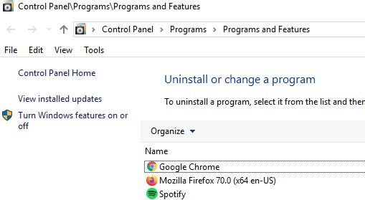
The Add / Remove features button in Control Panel
On Windows Server, they can be managed in the Server Manager window. Click on the "Manage" tab in the top-right, then on "Add/Remove Roles and Features". From there, follow the prompts on-screen.

Roles to disable
All of them. Unless explicitly stated in the README, it shouldn't be there. Things like Telnet or FTP are common to see, and should always be removed (unless specified) due to security flaws.

Features to Disable
Remember: the README takes priority over all instructions here. If the README says to keep it, you keep it.
- Active Directory Services
- Internet Information Services
- Internet Information Services Hostable Web Core
- Media Features
- Print and Document Services
- RIP Listener
- Simple TCP/IP
- SMB
- SNMP
- Telnet
- Work Folders
- XPS Services

12 – Group Policy (Windows only)
The Group Policy Editor (gpedit.msc) is where most of the actual configuration happens on Windows computers. In here, you can manage near-on every aspect of the computer. From auditing to Windows Update, there's an endless array of options to edit. Best part, they're all organized in a handy directory tree, just like files.

Control Panel
- Personalization/Enable screen saver
Recommended: Enabled

Network
- Network Connections/Windows Firewall
Recommended: For all profiles, set "Windows Firewall: Protect all network connections" to Enabled

Windows Components
- Autoplay Policies/Turn off Autoplay
Recommended: Enabled for all drives
This is the rationale blurb.
- Remote Desktop Services/Remote Desktop Session Host/Connections/Allow user to connect remotely using Remote Desktop Services
Recommended: Disabled
You should not allow remote access to your computer. It is a security risk.
- Remote Desktop Services/Remote Desktop Session Host/Security/Require secure RPC communication
Recommended: Enabled
Only if RDP is enabled.
- Remote Desktop Services/Remote Desktop Session Host/Security/Require user authentication for remote connections by using Network Level Authentication
Recommended: Enabled
Only if RDP is enabled.
- Search/Allow Cortana
Recommended: Disabled
Annoying, unecessary, and probably insecure somehow.

13 – Remote Desktop Protocol (Windows only)
This should only be enabled if Remote Desktop Protocol is required via the README. To enable RDP, open the start menu then search Control Panel, then in the top-right search “Remote Desktop” and then enable it.
To enable extra security for RDP, go to the Start Menu and search for “Registry Editor.”
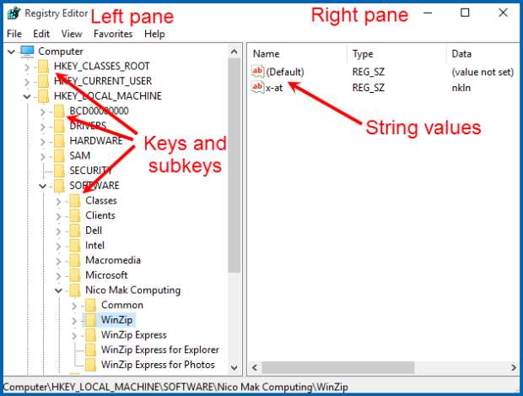
Navigate to: Local Computer Policy → Computer Configuration → Administrative Templates → Windows Components → Remote Desktop Services → Remote Desktop Session Host → Security → Require use of specific security layer for remote (RDP) connections
Enable, and set security layer to SSL

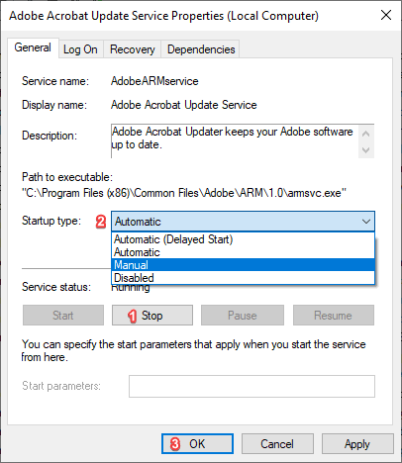

If the README does not mention RDP, hten you can disable it in the Services program. Open the Start Menu and search “Services” then open it.
Set the following to disabled:
- Remote Access Connection Manager
- Remote Desktop Configuration
- Remote Desktop Services

14 – Internet Information Services (IIS) Manager (Windows Server only)
This is where you can manage the network server on Windows Server. This can be used to find the awnser for forensic questions, like finding the location of a network folder. To open IISM, go to the Start Menu and type “inetmgr” then open it. It should open a window with a bunch of tools and a tree on the left, similar to the Local Security Policy.
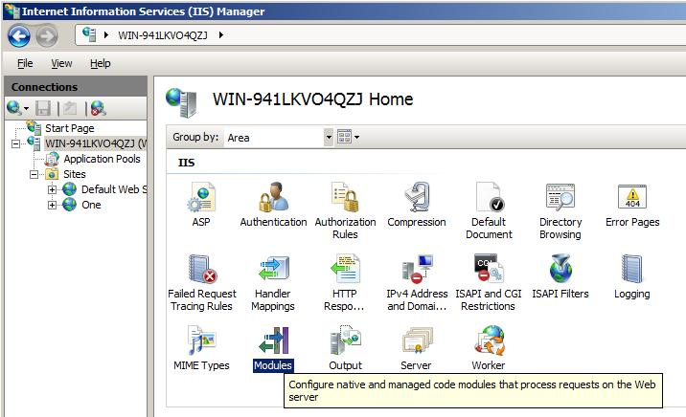
Drop down on the left pane until you get to the website, “Default Web Site.” From here, you should be able to find the folder by clicking the “Directory Browsing” or right-clicking the Default Web Site and going to properties.

You can find the answer to many a forensic question using this helpful tool. (Thank you to Danica for finding this one out!)

15 – Cron (Linux only)
Cron is the tool on all Linuxes that starts programs at certain times. It does this with the crond service, which uses /etc/crontab . This has its uses but can often be used to do remote attacks. If the README/Forensic questions ask about a backdoor starting then this is a good place to look.

If you see any suspicious files here (such as .py python files, or ones not shown below) Then note it in any questions and remove them. (Some forensic questions may ask for info about the file shown in the crontab, so don’t remove it before taking note!)

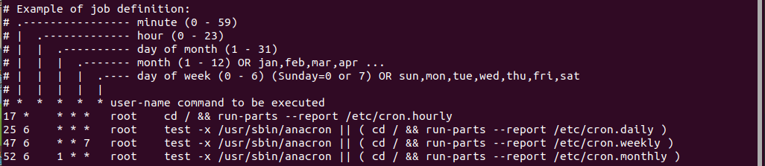
To start the cron service, use the systemctl command with sudo .

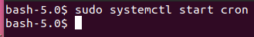

Cron also has various folders that work the same as the entries in /etc/crontab . /etc/cron.d , /etc/cron.daily , /etc/cron.weekly and /etc/cron.monthly . Each executable in these is ran according to the folder’s date text. (Ex. Monthly is ran every month) And, /var/spool/cron/crontabs is a lesser-known crontab location for printers, which is a good place to check just in case.

16 – Windows Defender (Windows only)
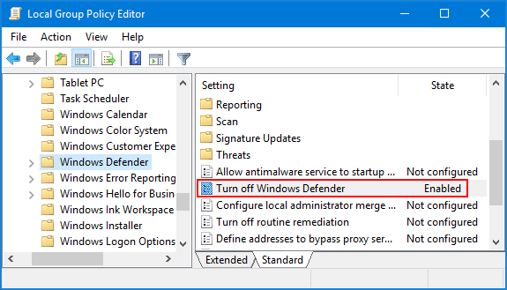
Some Windows images require Windows Defender to be enabled. To do this, you can use the Local Group Policy Editor. Open the start menu and type “gpedit.msc”, Local Group Policy Editor should pop up. In the newly opened window, navigate to:
Local Computer Policy → Computer Configuration → Windows Settings → Administrative Templates → Windows Components → Windows Defender
disable “Turn off Windows Defender” (Confusing, I know)

The location might change a bit depending on configuration/Windows version.

17 – Windows Services (Windows only)
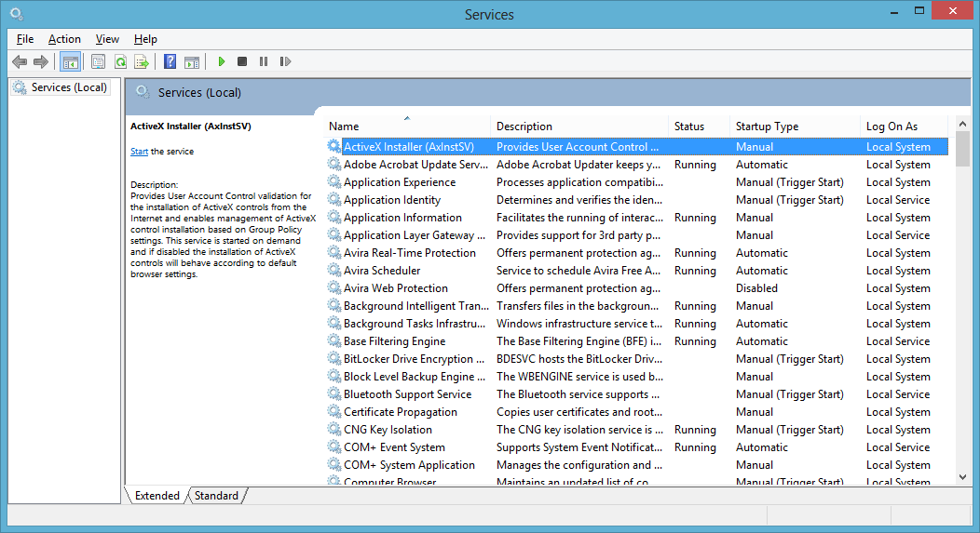
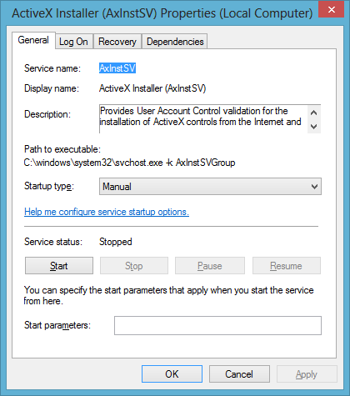
Certain scenarios require you to make sure a service is running or stopped. To open the services window, type “services.msc” into the Start Menu and open it. It should look like this:

Right click on a service and go to Properties to change Startup type, or to start/stop the service.

The Properties menu also shows the Path to the executable.

Services to Disable
- ActiveX Installer
- Adaptive Brightness
- Application Layer Gateway Service
- Bluetooth Support Service
- Certificate Propogation
- Fax
- NetMeeting Remote Desktop Sharing - VoIP
- Parental Controls
- Plug and Play
- Print Spooler
- Remote Registry
- RIP Listener
- Routing and Remote Access
- Simple File Sharing
- SNMP Trap
- SSD Discovery Service
- SSDP Discovery
- TCP/IP NetBIOS Helper
- Telephony
- Universal Plug and Play Device Host
- UPnP Device Host
- Windows Messenger Service

Services to Enable (If README deoes not specify. Otherwise disable. For exampl,e the README will put “ftp” under Critical Services. Enable that. If it does not mention Telnet, then disable it.)
- Microsoft FTP Service
- FTP
- Remote Desktop Help Session Manager
- Remote Desktop Configuration
- Remote Desktop Services UserMode
- Server (do not disable on Windows server)
- Telnet
- Event log

Also make sure to enable any services listed in the README.

18 – Listing programs
Weither for forensic questions or just to check on something, it can be useful to have a readout of everything running on the system.

The following is for Linux
There are a multitude of ways to view all running programs on Linux, some more readable than others. The most easy way to view processes is using the System Monitor on Ubuntu (run by opening the apps menu in the bottom-left and clicking the heart-rate looking monitor), or the Task Manager in Linux Mint (search in the Start Menu in the bottom left)
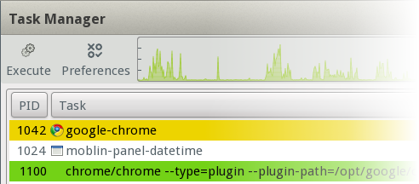
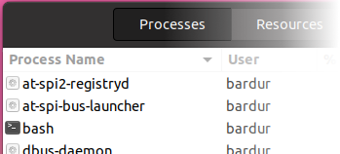
If you would prefer to use the Terminal to see all programs, first open the Terminal then use one of two commands:
the top command, which shows an interactive list of all running programs. (press “q” to quit)
The ps -xa command, which spits out all running programs into the terminal.

The following is for Windows
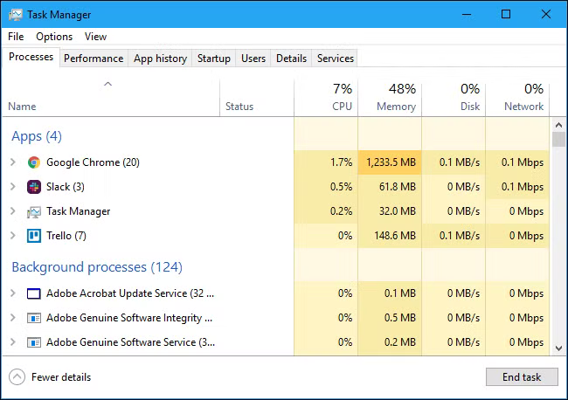

To view all running programs on Windows you can use the Task Manager. To open it, type “Task Manager” into the start menu then open what comes up. It will look something like this:
From here, you can right click any program and view where it is on the disk, or kill it with “End task.”

Inside of task manager on the “Startup” tab, you can check to see what programs auto-start on boot. If there is anything suspicious, you may want to investigate.

19 – Ports
Some Forensic questions might ask you to get the port of a running process. On both Linux and Windows, you can use the netstat command to view all open ports. To see internet ports, use the -tulpn option(s). netsat has a ton of options. To view them, use netstat -h on Linux, or netstat /h on Windows.
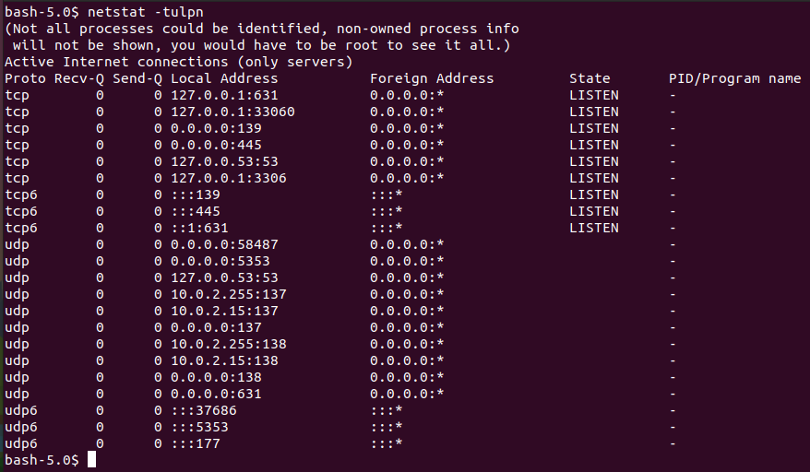
On Windows, use the Command Prompt. (Search cmd.exe in the Start Menu then open)
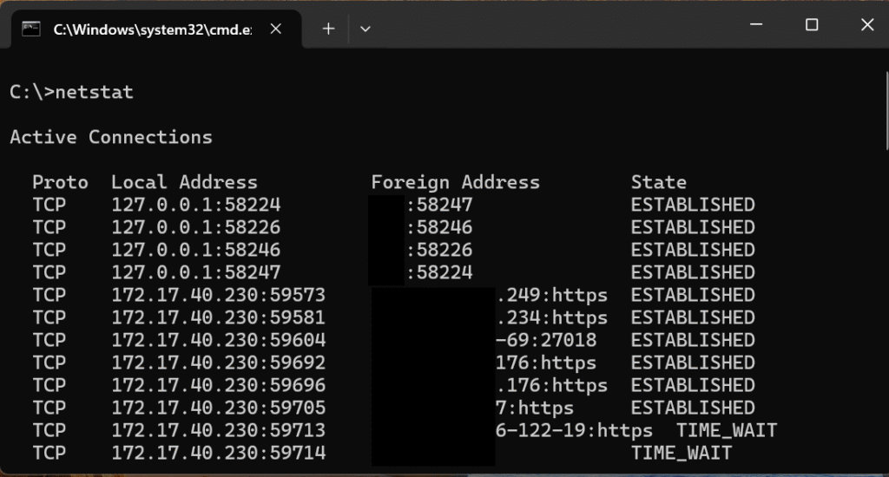

20 – Pam/General Security

The following is for Linux
In /etc/security/faillock.conf, add or edit the following lines:
deny = 5
unlock_time = 900
root_unlock_time = 60
For pam_pwquality, there is a hierarchy to which settings take priority. Module arguments in the common-* files override settings in /etc/security/pwquality.conf . Settings in files in /etc/security/pwquality.conf.d/ are overridden by either. It is recommended by the CIS to use a *.conf file in /etc/security/pwquality.conf.d/ for "clarity, convenience, and durability."

Include the following lines in /etc/security/pwquality.conf :
difok = 2
minlen = 14
minclass = 0
dcredit = 0
ucredit = 0
ocredit = 0
lcredit = 0
maxrepeat = 3
maxsequence = 3
enforce_for_root

The following is for /etc/login.defs
PASS_MAX_DAYS should be 130
PASS_MIN_DAYS should be 30
PASS_WARN_AGE should be 0

/etc/shadow should not be world readable. Run chmod 600 /etc/shadow
The following is for /etc/sysctl.d/99-sysctl.conf :
net.ipv4.tcp_syncookies = 1
net.ipv4.ip_forward = 0
And the following commands should be ran:
sudo sysctl -w net.ipv4.ip_forward=0
sudo sysctl -w net.ipv4.tcp_syncookies=1
If mysql is needed by the README, edit /etc/mysql/mysql.conf.d/mysqld.cnf :
under [mysqld] :
bind-address = 127.0.0.1
skip-grant-tables
If proftpd is needed by the README, edit /etc/proftpd/proftpd.conf :
UseIPv6 Off
DefaultRoot /var/chroot
If apache2 is needed by the README, edit /etc/apache2/conf-available/security.conf :
ServerTokens Prod
if you have apache and the old php 7.0, edit /etc/php/7.0/apache2/php.ini :
expose_php = Off

If you have /var/www/html/webshell.php , delete it.
rm /var/www/html/webshell.php
The following is for Windows
Most of these involve the Control Panel.

Disabling Dump File Creation
Under System > Advanced > Startup/Recovery > Settings
Set "Write Debugging Information" to "None"
Go to User Accounts and Family Safety > Manage you credentials
Delete all listed credentials until there are no entries in any box. This means removing both Windows and Web credentials.
Under System and Security > Power Options
Require a password on wakeup
User Account Control. This is the screen that pops up when you need administrator access to do something on Windows.
You can enable it under System and Security → Action Center → Change User Account Control settings . Move the bar all the way up to its maximum setting.

